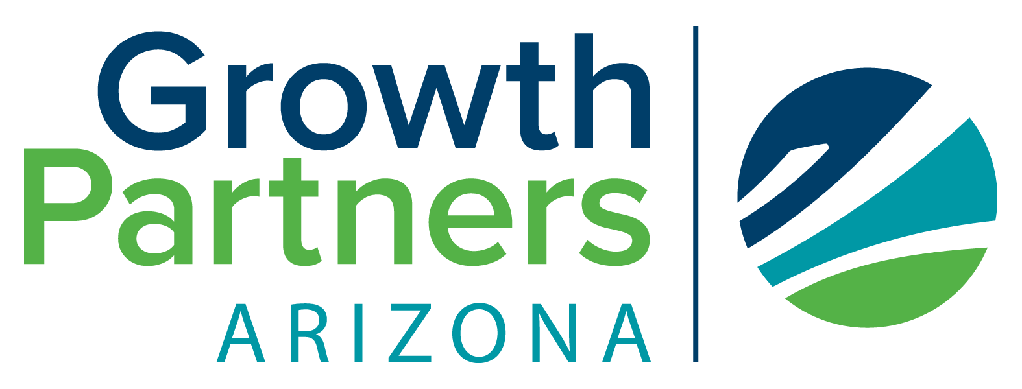
Value Proposition Playbook
This playbook is your step-by-step guide to discovering and refining one of the most powerful tools in your business toolkit—your Value Proposition. Whether you’re a product-based entrepreneur, service provider, or nonprofit leader, this resource will help you clarify your message, attract the right people, and grow with purpose.
Inside, you’ll find:
- Easy-to-follow worksheets to identify your ideal customer
- Exercises to uncover customer pain points and goals
- A framework to map your offer to your customer’s needs
- A fill-in-the-blank formula to craft your value proposition
- Tips for testing, refining, and using your value message across your business
What is a Value Proposition?
Your value proposition is a clear, concise statement that explains what you offer, who it's for, how it helps them, and why they should choose you over others. It's not just about your product—it's about the problem you solve and the value you deliver.
Why It Matters | A strong value proposition:
- Attracts your ideal customers
- Differentiates your business in the market
- Increases clarity and confidence in your messaging
- Helps guide product development and marketing decisions

Know Your Customer
Complete the following to better understand your target customer: Customer Persona Questions:
- What is your ideal customer age range:
- What is your ideal customer occupation/role:
- What is your ideal customer’s biggest challenge:
- What are they trying to achieve?
- What frustrates them about current options?

Identify Customer Pains and Gains
List your customer’s biggest pain points:

List the gains your customer is seeking (what success looks like to them):\

Map Your Offer
List your key products or services:

How does your offer relieve customer pains?

How does your offer help them achieve their goals?

Write Your Value Proposition
Use this formula as a starting point:
"I help [TARGET CUSTOMER] do [TASK/GOAL] so they can [DESIRED OUTCOME], without [BIGGEST PAIN POINT]."
Draft your statement below:
First draft:

Refined version:

Test and Refine
Share your value proposition with customers, peers, or mentors. Ask:
- Is it clear who this is for?
- Does it explain how the offer helps?
- Is it emotionally and practically compelling?
- Refine based on feedback until it feels right.
Use Your Value Proposition for Market Differentiation
Your value proposition is one of your strongest tools for standing out in a crowded market. It helps clearly communicate why a customer should choose your business over others. Here's how to use it strategically:
- Highlight unique features, outcomes, or benefits your competition doesn't offer.
- Emphasize your specialty or niche—be the expert in one thing rather than a generalist in everything.
- Use your customers’ language. Speak directly to their pains and desires in a way that resonates emotionally.
- Consistently repeat your value proposition across platforms to build recognition and trust.
Conclusion: A Foundation for Every Offer
Your value proposition isn’t just a marketing tool—it’s a foundation that supports every product, service, and customer interaction. Whether you offer multiple services or a suite of products, you can craft a value proposition for each one, tailored to the audience it serves. This allows you to maintain clarity while reaching different segments of your market.
When used consistently, your value proposition becomes a filter for business decisions, a tool for growth, and a voice that carries your message into every conversation. With this playbook, you now have the tools to build a message that connects, converts, and creates meaningful relationships with the people you serve.
Use it, test it, refine it—and watch your business grow with purpose and clarity.

How to Use Your Value Proposition
Once you've crafted your value proposition, it becomes the foundation for clear and consistent communication. Here’s how to put it to work:
Website & Landing Pages
Place your value proposition prominently on your homepage or service pages. It should be the first thing visitors see—clear, bold, and benefit-driven.
Social Media Bios & Posts
Incorporate your value proposition or elements of it into your Instagram bio, LinkedIn headline, or pinned Facebook post. Let people know right away how you help.
Marketing Materials
Use your value proposition to guide brochures, flyers, or email campaigns. It ensures all your content speaks directly to your customer’s needs.
Sales Conversations
A refined value proposition helps you answer the “What do you do?” question with confidence. It becomes your elevator pitch—quick, compelling, and tailored.
Product or Service Development
Refer back to your value proposition when creating new offers. Does it align with the needs and desires of your ideal customer? If not, adjust before you launch.
Grant or Loan Applications
For nonprofits or community-focused businesses, your value proposition can strengthen funding applications by clearly showing your community impact.

